Authored By: Mallory Schroeder

TABLE OF CONTENTS Page
1. References 1
2. Appendix Contents 2
3. Scope 3
4. Purpose 3
5. Background 3
6. Materials 3
7. Risk Assessment 5
8. Experiment Design / Sample Size Justification: 5
9. Procedure 8
10. Acceptance Criteria 15
11. Appendices 17

References
ENG-RPT-418 | Product Specification Verification Test Report
ENG-PRT-290 | Product Specification Verification Test Protocol
ENG-RPT-503 | Shipping Test – Zip Pen 2525-15
ENG-PRT-327 | Shipping Test – Zip Pen 2525-15
ENG-RPT-569 | Aged, Non-Aged Zip Tubing Strength Comparison Report
MKT-CMR-029 | MEGADYNE Smoke Evacuation Product Line CMR
ENG-PS-007 | Product Specification, Smoke Evacuation Pencil and Accessories
ENG-PS-010 | Product Specification, Disposable Electrosurgical Pencil
MKT-US-002 | Usability Requirements Specification, Smoke Evacuation Pencils, Extension Nozzles and Universal ULPA Filter
ENG-IOM-012 | Input/Output Conformance Test Matrix, Zip Project
5800309 | Nozzle Extension, (0014A), Zip
5800308 | Nozzle Extension, (0014), Zip
5800099-01 | Connector, Proximal 22mm
5800104-01 | Nozzle, Zip
4100058-02 | Convoluted Tubing 56”
4100058-01 | Convoluted Tubing 8”
6020191-01 | Zip Pen 15ft Sub Assy
6020312 | Sub-Assy, EC, 10 Foot Zip
QA-SOP-012 | Sampling and Statistical Techniques

Appendix Contents
- Cable & Tube Length, Connector Dimension, Swivel Distance Acceptance Sheet
- E-Z Clean Coating Acceptance Sheet
- Holster, Plug, Cord Color Acceptance Sheet
- Plug Branding Acceptance Sheet
- Angled, Clarity Nozzle Acceptance Sheet
- Cord Exit Length Acceptance Sheet
- Cord Containment Acceptance Sheet
- ESU Physical Plug Compatibility Acceptance Sheet
- Extension Nozzle Length Acceptance Sheet
- 2211 ULPA Filter Attachment Acceptance Sheet

Scope
This protocol pertains to the Zip Pen products identified in MKT-CMR-029, including cat numbers 2525-10 (252510), 2525-10EC (252510EC), 2525-10BN (252510BN), 2525-10ECBN (252510ECBN), 2525-15EC (252515EC), and 2525-15 (252515), ME7251C, ME7251E, ME725M1C, ME725M1E. These Zip products share the same design, differing only in cord / tubing length, active electrode type, and/or packaging. This protocol also pertains to the Extension Nozzle cat numbers 2540 (2540J) and 2560 (2560J). The catalog numbers in parentheses are new catalog numbers referring to the same product, due to transition of product information from Megadyne Medical Products to Ethicon Endo Surgery. The old and new catalog numbers are interchangeable as it relates to referencing a product.

Purpose
The purpose of this test protocol is to verify requirements to show compliance with customer and marketing level (MKT-CMR-029), usability (MKT-US-002) and product specification (ENG-PS-007) requirements that are not tested under other protocols.

Background
The Zip Pen is a smoke evacuation pencil for Megadyne. The ULPA Replacement Filter is an existing accessory that has been redesigned and sourced from a different supplier. These accessories have been the subject of several verification protocols. This protocol is intended to document additional evidence for verification of requirements. For all other test documentation, refer to Input/Output Conformance Test Matrix ENG-IOM-012.

Materials

Calibrated Calipers

Calibrated Measuring Tape or Yard Stick

Competitive ESUs

ConMed Sabre 2400

Valleylab Force 2

Erbe ICC 350

Force Triad

Force FX

Erbe VIO 300D

ConMed System 5000

Zip-Pen (252510EC, 252515)

Aged Samples (Source: Lot # S160050, proof of aging and shipped testing in ENG-PRT-327, ENG-RPT-503)

Non-Aged Samples (Source: Pulled from Warehouse)

Extension Nozzles (2560J, 2540J)

Non-Aged Samples (Source: Pulled from Warehouse)

Instron Force Tester

ULPA Filter (2211J)

Non-Aged Samples (Source: Pulled from Warehouse)

Connector Filter/Tubing (2140)

Non-Aged Samples (Source: Pulled from Warehouse)

Pantone Color Chips

Risk Assessment

Document ENG-RMF-045 (Risk Analysis, Smoke Evacuation Accessories) identifies the risk associated with these devices. The items below relate to testing here.

Line ID | Failure Mode | Cause | Mitigation | Verification
30-d | Tubing disconnects from connector | Improper tubing material specified | Test mechanical pull strength of tubing from connectors | Test Report ENG-RPT-329
24-a | User not aware of product brand | Branding not on product | Design with brand on the product | Test Report ENG-RPT-418
29-d | Plug difficult to insert into ESU | Incorrect plug pin spacing, pins too large | Design for compatibility, test for insertion force comparable to similar devices | Test Report ENG-RPT-329
43-a, 44-a | Incorrect electrode to Nozzle Size | Electrode too short, cannot do surgery without removing nozzle. Electrode too long, poor smoke capture | Put compatibility statement in IFU | IFU MKT-LBL-531

Experiment Design / Sample Size Justification:

There are several attributes part of this test which do not exhibit variation as it relates to the acceptance criteria. For these attributes one (1) part/device will be inspected along with the documentation controlling the presence of that attribute. For dimensional measurements, critical dimensions (as defined by diamonds on the print) are measured during incoming inspection on a sample of the product. Most components are molded and experience minimal variation relative to the specification. Therefore, the sample size for dimensional measurements is three. For comparative tests, 11 samples will be used. For functional measurements, 30 samples will be used (per QA-SOP-012). The majority of product attributes are shared between all Zip product codes, and thus a single catalog number can be used to verify the attributes of all catalog numbers previously listed, with the exception of attributes such as cable and tube length. Sterilized samples will be used. Accelerated aged products will be used to meet ENG-PS-007 requirement PRS 2001, with justification provided if non-aged samples are used.

A summary of the experimental design is as follows:
Test Description | Test Type | Sample Size | Requirement Linkage | Justification for non-aged or ship testing
Cable & Tube Length, Connector Dimension, Swivel Distance | Drawing comparison, Measurement | 252510EC (3)  252515 (3) | MKT-CMR-029 | Transportation and aging do not affect length
E-Z Clean Coating | Drawing comparison, Pass/Fail | 252510EC (1)  252515 (1) | MKT-CMR-029 | Transportation and aging do not affect presence of the coating
Holster, Plug, Cord Color | Drawing inspection, Pass/Fail | 252515 Accelerated Aged (1) | MKT-CMR-029, PRS 1103, PRS 1109, URS 1002 | Transportation does not affect the color
Plug Branding | Drawing inspection, Pass/Fail | 252515 (1) | MKT-CMR-029, PRS 1104 | Transportation and aging do not affect presence of the branding
Angled, Clarity Nozzle | Drawing inspection, Pass/Fail | 252515 – Accelerated Aged (1)  or  2540J – Accelerated Aged (1)  or  2560J – Accelerated Aged (1) | PRS 1113 | Transportation does not impact the molded angle of the nozzle or the clarity. Aging does not have an impact on the angle.
Cord Exit, Tube Containment Length | Drawing inspection, Measurement | 252510EC (3)  252515 (3) | MKT-CMR-029, PRS 1110 | Transportation and aging do not affect length
Cord Containment | Functional  Pass/Fail | 252515 – Accelerated Aged and Ship Tested (11) | MKT-CMR-029, PRS 1109 | N/A
ESU Physical Plug Compatibility | Pass/Fail, Statement | 252515 –Accelerated Aged and Ship Tested (1) | MKT-CMR-029 | N/A
Plug Extraction Force | Functional,  Instron Measurement | 252515 –Accelerated Aged and Ship Tested (30) | MKT-CMR-029, PRS 1310 | N/A
Extension Nozzle Length | Drawing inspection, Measurement | 2540J (3)  2560J (3) | MKT-CMR-029 | Transportation and aging do not affect dimensions
2211 ULPA Filter Attachment | Drawing inspection, Pass/Fail | 2211J (1)  2140 (1) | MKT-CMR-029 | Transportation and aging do not affect molded connection dimensions
EC Connector Instron Pull Test | Functional Comparison,  Instron Measurement | 252510EC – Non-Aged (11) | URS 2001, PRS 1308 | ENG-RPT-569; Transportation and aging do not affect tubing connections
Cable, Plug Cytotoxicity | Document | N/A | PRS 1504 | N/A
2211 ULPA Filter Efficiency | Document | N/A | MKT-CMR-029, PRS 1314 | N/A

Procedure
NOTE: If operator other than originator conducts testing, ensure proper training is conducted, and documentation of training is provided in the report.

Cable & Tube Length, Connector Dimension, Swivel Distance

Obtain 3 samples each of 252510EC and 252515.

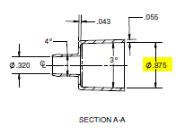
Measure the length of the cord and tubing of 252510EC and 252515 using measuring tape. Record the value in Appendix I.

Measure the ID of the EC 22mm Connector of the 10’ Zip using calipers, at the widest point. Refer to the dimension in Figure 1. Record the value in Appendix I.
Figure 1

Repeat for each of the three samples.

E-Z Clean Coating

Obtain 1 sample each of 252510EC and 252515 and inspect the electrode

Verify the electrode is coated with E-Z Clean, record acceptance in Appendix II.

Holster, Plug, Cord Color.

Obtain 1 sample of 252510EC.

Verify the holster, plug, and cord are Grey Pantone 427, using Pantone color blocks.

Record results in Appendix III.

Plug Branding

Obtain 1 sample of 252510EC.

Verify the plug has ‘Megadyne’ branding per Zip Assembly Drawing 6020312-01.

Record results in Appendix IV.

Angled Nozzle, Clarity

Obtain 1 sample each of 252510EC, 2540J, 2560J

Verify the nozzles have angled tips, and the nozzles are clear, not opaque.

Record results in Appendix V.

Cord Exit, Tube Containment Length

Obtain 3 samples each of 252510EC and 252515

Measure the length of the cord exiting the tubing of 252510EC and 252515 using measuring tape (from tubing exit to plug). Record the value in Appendix VI.

Measure the length of the cord contained within the tubing of 252510EC and 252515 using measuring tape (from tubing exit to Zip Pen body). Record the value in Appendix VI.

Repeat for each of the three samples.

Record results in Appendix VI.

Cord Containment

Obtain 11 samples of accelerated aged and ship tested 252515 products (Ship Test described in ENG-RPT-503)

Verify the paper tape is still present and wrapped around the cable.

Verify the cord is still wrapped and contained within the holster.

Record results in Appendix VII.

ESU Plug Physical Compatibility

Obtain 1 aged Zip sample.

Insert the plug of the 252510EC into each competitive ESU listed in Materials section 6.3. NOTE: This is testing the physical fit of the standard 3 prong plug to standard monopolar ESU ports, not holistic compatibility.

Turn the ESU on. Ensure power settings are suitable for activation (not in standby mode).

Press the cut button. Press the coag button.

Verify the Zip Pen activates and the plug remains attached after insertion. NOTE: Should the connection become too lose for acceptance, obtain a new Zip sample. As a single use device, Zip Pens are intended to be plugged in one time.

Record results in Appendix VIII.

Plug Extraction Force

Obtain 30 samples of aged, sterilized Zip.

Use the 100 lb load cell in the Instron.

Place a representative Mega Power ESU connector block in the lower jaws of the Instron (Figure 3).

Insert the plug into the connector block (Figure 3).
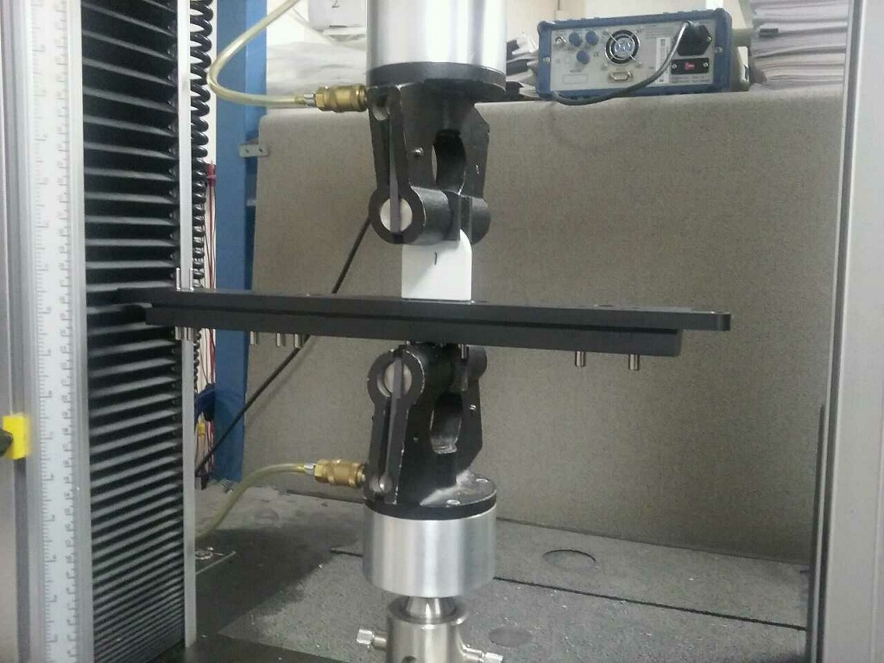
Figure 3

Lower the upper jaws of the Instron so that they can grasp the initial 0.25” of the test plug. Actuate the jaws to grasp the plug.

Program the Instron for a speed of 7.87 inches per minute (200mm per minute) and a travel distance of 0.1 inches (2.54mm).

Select “Balance Load” to zero the load cell.

Pull the plug out of the connector measuring the extraction force.

Repeat for each of the samples.

Sign and date the print out of the results for use in the test report.

Extension Nozzle Length

Obtain 3 samples each of 2540J and 2560J.

Measure the longest axis of the nozzle, along centerline.

Repeat for each of the three samples.

Record results in Appendix IX.

2211 ULPA Filter Attachment

Obtain 1 sample of 2211 ULPA filter and a 2140 connector. NOTE: The 2140 connector is the threaded connector component of 2110-10 / 2110-09 UltraVac Pencils. Either a standalone 2140 connector or an UltraVac can be used, as the connectors are the same components.

Insert the threaded 2140 connector into the ULPA filter threaded connector.

Record results in Appendix X.

EC Connector Instron Pull Test

Obtain 11 samples of 252510EC.

Program the Instron for a speed of 7.87 inches per minute (200 mm per minute) and a travel distance of 12 inches (2.54 mm). Use the ten pound load cell.

Secure a filter with a 7/8” port to the base of the Instron using straps or a large vice.

Securely insert the 22 mm EC connector into the 7/8” port.

Clamp the tubing in the upper jaws of the Instron with an approximately 10 inch gap between the upper jaws and the 22 mm connector (Figure 4)
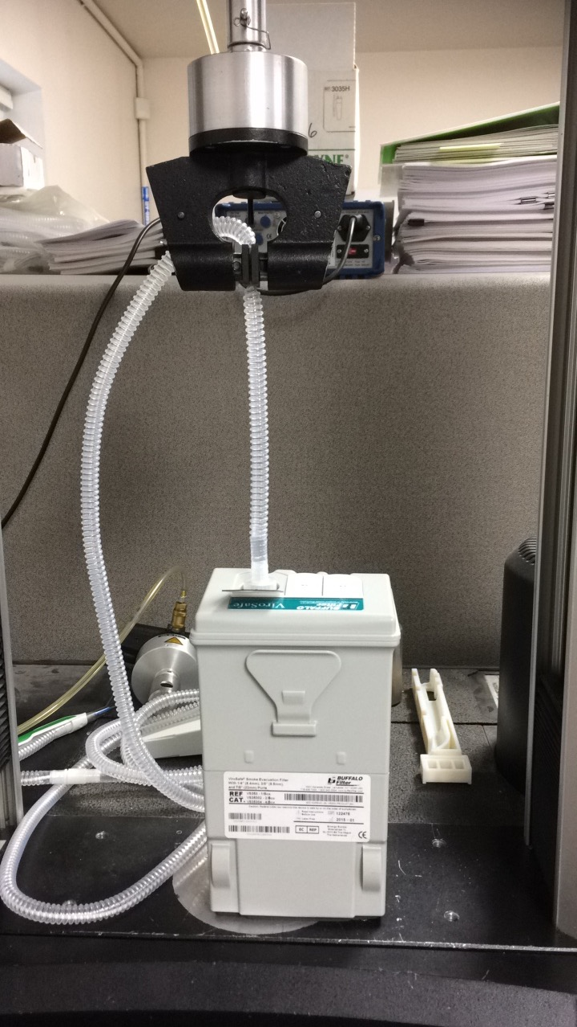
Figure 4

Select “Balance Load” to zero the load cell.

Select Start and pull the tubing until the connection disengages.

Repeat for the remainder of samples.

Sign and date the print out the results for use in the test report.

Cable, Plug Cytotoxicity

Acquire documentation for past cytotoxicity testing of the cable and plug materials.

Include documentation in test report.

2211 ULPA Filter Efficiency

Acquire documentation for past filter efficiency testing.

Include documentation in test report.

Acceptance Criteria
The following acceptance criteria must be met, or a sourced document demonstrating the same acceptance criteria must be provided.

Cable & Tube Length, Connector Dimension, Swivel Distance

Cable length shall be 10 feet for 252510EC and 15 feet for 252515, +/- 6 inches for measurement error. There is no tolerance for Zip Pen cable length on print, only called out as quantity in BOM within 6020191-01 rev 005 and 6020312 rev 007. Tolerance is therefore taken from ENG-PS-010 4.2.6.

Tube length should be 120 inches for 252510 +/- 2.6 inches and 176 in for 252515EC, +/- 3.6 inches per 4100058-01 rev 003 and 4100058-02 rev 003 Length and tolerance determined by adding tolerances for each tubing segment, including note to trim 8.5” tubing segment within 6020191-01 rev 005 and 6020312 rev 007.

The ID of the 22 mm Connector shall be 0.875in, +/- 0.005in per 5800099-01 rev 005.

Swivel Distance shall be approximately 8in from the Zip Pen handle, +/- 1in for measurement error.

E-Z Clean Coating

The blade shall be coated with proprietary E-Z Clean coating.

Holster, Plug, Cord Color.

The holster, plug, and cord should be gray Pantone 427.

Plug Branding

The Megadyne name will be molded into the plug clam shell.

Angled Nozzle, Clarity

Each nozzle shall have an angled end, and be clear not opaque.

All nozzles (Zip nozzle, 2540J, 2560J are composed of the same material per 5800104-01 rev 003, 5800308 rev 002, 5800309 rev 002). Therefore, acceptance for clarity of one aged sample signifies acceptance of all.

Cord Exit, Tube Containment Length

Each cord length exiting the tube shall be at least 4 feet in length.

Each length of cord assembled inside the tube should be at least 64 inches in length.

Cord Containment

The paper shall be present and wrapped around the cable.

The cord shall be wrapped and contained within the holster.

ESU Plug Compatibility

The plug shall physically fit each ESU with standard three prong monopolar ports—see specific units listed in Materials. There is no specification around specific devices that must be compatible with the exception of Megadyne ESUs which are tested elsewhere.

Plug Extraction Force

Plug extraction force should be at least 6.0 lbs.

Extension Nozzle Length

Average length of 2140J should be 2.79 inches and 2160J should be 5.29 inches, each+/- 0.02 inches per 5800309 rev 002 and 5800308 rev 002.

2211 ULPA Filter Attachment

The threaded 2140 connector should be capable of being attached with the 2211 ULPA Filter. These parts are molded and designed for compatibility.

EC Connector Instron Pull Test

Tubing to connector strength should be at least 4.0 lb.

Cable, Plug Cytotoxicity Acceptance Sheet

Documentation shall be provided for past successful cytotoxicity testing of cable and plug materials.

2211 ULPA Filter Efficiency Acceptance Sheet

Documentation shall be provided for past filter efficiency testing demonstrating 99.999% efficiency for particles 0.1 to 0.2 micron.

Appendices

Appendix I:
Cable & Tube Length, Connector Dimension, Swivel Distance

252510EC

Catalog Number: Lot Number:

Sample Number | 22mm Connector Diameter | Tube Length | Cord Length | Swivel Distance from Handle
1
2
3

Matches Drawing 5800099-01 Rev 005, 6020312 Rev 007: YES/NO

252515

Catalog Number: Lot Number:

Sample Number | Tube Length | Cord Length | Swivel Distance from Handle
1
2
3

Matches Drawing 6020191-01 Rev 005: YES/NO

Test Conducted By (Name):_________________________________ Date:_____________

Test Conducted By (Signature):__________________________________

Comments:

Equipment Name, Number, Cal Date, Cal Due Date:

Appendix II
E-Z Clean Coating

252510EC

Catalog Number: Lot Number:

Electrode is Coated with E-Z Clean: YES/NO

252515

Catalog Number: Lot Number:

Electrode is Coated with E-Z Clean: YES/NO

Test Conducted By (Name):_________________________________ Date:_____________

Test Conducted By (Signature):__________________________________

Comments:

Appendix III
Holster, Plug, Cord Color

252510EC

Catalog Number: Lot Number:

Holster Color is Pantone 427: YES/NO

Plug Color is Pantone 427: YES/NO

Cord Color is Pantone 427: YES/NO

Matches Drawing 6020312 Rev 007: YES/NO

Test Conducted By (Name):_________________________________ Date:_____________

Test Conducted By (Signature):__________________________________

Comments:

Appendix IV
Plug Branding

252510EC

Catalog Number: Lot Number:

Plug has ‘MEGADYNE’ Branding: YES/NO
Matches Drawing 6020312 Rev 007: YES/NO

Test Conducted By (Name):_________________________________ Date:_____________

Test Conducted By (Signature):__________________________________

Comments:

Appendix V
Angled Nozzle, Clarity

252510EC

Catalog Number: Lot Number:

Nozzle is Angled: YES/NO
Nozzle is Clear and Not Opaque: YES/NO
Material Name from 5800104-01 Rev 003: ________________________

2540J

Catalog Number: Lot Number:

Nozzle is Angled: YES/NO
Material Name from 5800309 Rev 002: ________________________

2560J

Catalog Number: Lot Number:

Nozzle is Angled: YES/NO
Material Name from 5800308 Rev 002: ________________________

Test Conducted By (Name):_________________________________ Date:_____________

Test Conducted By (Signature):__________________________________

Comments:

Appendix VI
Cord Exit, Tube Containment Length

252510EC

Catalog Number: Lot Number:

Sample Number | Cord Exit Length | Cord Length Within Tubing
1
2
3

252515

Catalog Number: Lot Number:

Sample Number | Cord Exit Length | Cord Length Within Tubing
1
2
3

Test Conducted By (Name):_________________________________ Date:_____________

Test Conducted By (Signature):__________________________________

Comments:

Equipment Name, Number, Cal Date, Cal Due Date:

Appendix VII
Cord Containment

252515 – Accelerated Aged and Ship Tested

Catalog Number: Lot Number:

Sample # | Paper Wrapped: Pass/Fail | Cord Wrapped and in Holster: Pass/Fail

Matches Drawing 6020191-01 Rev 005: YES/NO

Test Conducted By (Name):_________________________________ Date:_____________

Test Conducted By (Signature):__________________________________

Comments:

Appendix VIII
ESU Plug Compatibility

252510EC

Catalog Number: Lot Number:

ESU Name | Serial # | Pass/Fail | Comments

Test Conducted By (Name):_________________________________ Date:_____________

Test Conducted By (Signature):__________________________________

Comments:

Appendix IX
Extension Nozzle Length

2540J

Catalog Number: Lot Number:

Sample Number | Extension Nozzle Length
1
2
3

Matches Drawing 5800309 Rev 002: YES/NO

2560J

Catalog Number: Lot Number:

Sample Number | Extension Nozzle Length
1
2
3

Matches Drawing 5800308 Rev 002: YES/NO

Test Conducted By (Name):_________________________________ Date:_____________

Test Conducted By (Signature):__________________________________

Comments:

Equipment Name, Number, Cal Date, Cal Due Date:

Appendix X
2211 ULPA Filter Attachment

2211

Catalog Number: Lot Number:

2140

Catalog Number: Lot Number:

Connector is Compatible: YES/NO

Test Conducted By (Name):_________________________________ Date:_____________

Test Conducted By (Signature):__________________________________

Comments:

